🚀 Major Project 7 (FINAL):
Secure File Transfer using Zenity & SCP (AWS EC2)

1. Introduction
In modern computing environments, secure file transfer is a critical requirement, especially when working with remote systems and cloud infrastructure. This project demonstrates a secure and automated file transfer system using Zenity (GUI) and SCP (Secure Copy Protocol).

2. Objective

- To develop a GUI-based secure file transfer system
- To implement file transfer using SCP over SSH
- To automate remote file transfer using shell scripting
- To understand cloud-based communication using AWS EC2

🔧 3. Prerequisites
On Local VM:
Command: sudo apt update
sudo apt install zenity openssh-client -y
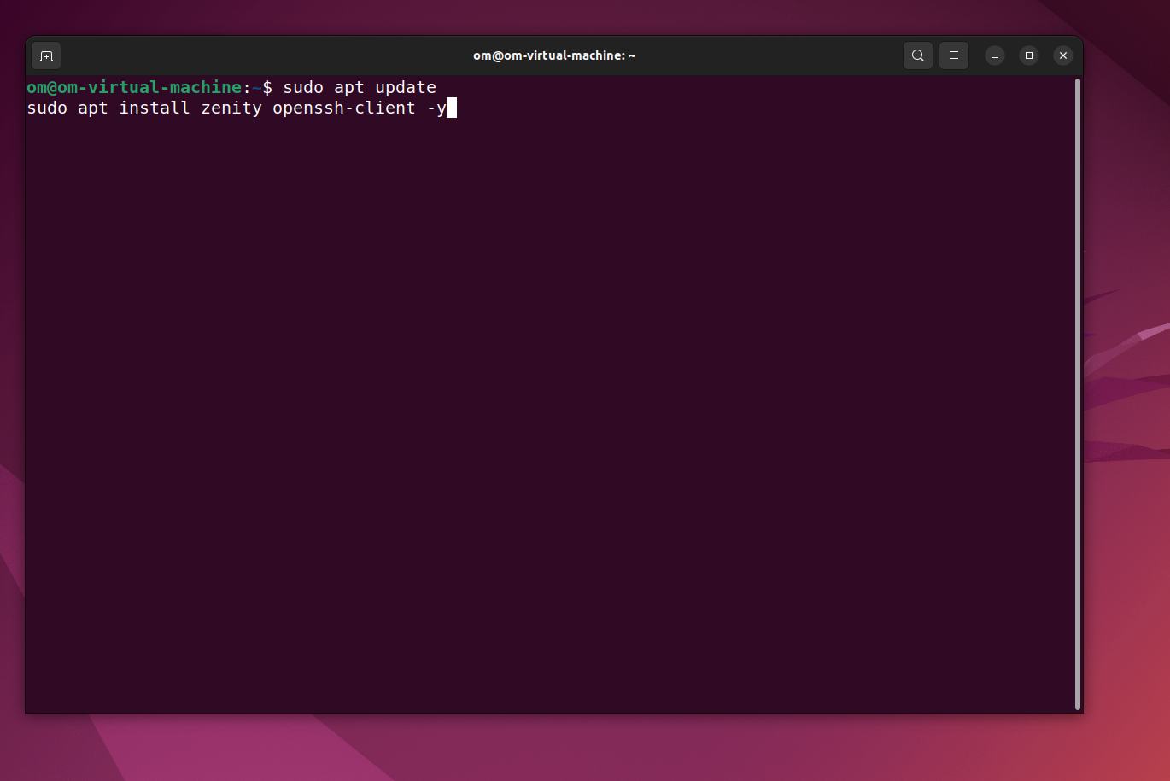

💻 4. Final Script (Production Version)
Create file:
Command : nano zenity_scp_final.sh
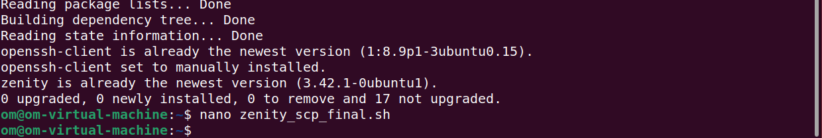

Paste this 👇
#!/bin/bash
TITLE="Secure File Transfer (Zenity + SCP + AWS)"
# Step 1: Select File
FILE=$(zenity --file-selection --title="Select File to Transfer")
if [ -z "$FILE" ]; then
zenity --error --text="No file selected!"
exit 1
fi
# Step 2: Enter EC2 Public IP
IP=$(zenity --entry --title="$TITLE" --text="Enter EC2 Public IP")
if [ -z "$IP" ]; then
zenity --error --text="IP Address required!"
exit 1
fi
# Step 3: Enter Username (default: ubuntu)
USER=$(zenity --entry --title="$TITLE" --text="Enter Username (e.g. ubuntu)" --entry-text="ubuntu")
if [ -z "$USER" ]; then
zenity --error --text="Username required!"
exit 1
fi
# Step 4: Select PEM Key
KEY=$(zenity --file-selection --title="Select PEM Key File")
if [ -z "$KEY" ]; then
zenity --error --text="PEM key required!"
exit 1
fi
# Fix permission automatically
chmod 400 "$KEY"
# Step 5: Destination Path
DEST=$(zenity --entry --title="$TITLE" --text="Enter Destination Path" --entry-text="/home/ubuntu/")
if [ -z "$DEST" ]; then
zenity --error --text="Destination required!"
exit 1
fi
# Step 6: Transfer with Progress
(
echo "10"; echo "# Connecting to EC2..."
sleep 1
echo "40"; echo "# Uploading file..."
scp -i "$KEY" -o StrictHostKeyChecking=no "$FILE" "$USER@$IP:$DEST"
if [ $? -eq 0 ]; then
echo "100"; echo "# Transfer Completed!"
else
echo "100"; echo "# Transfer Failed!"
exit 1
fi
) | zenity --progress \
--title="$TITLE" \
--percentage=0 \
--auto-close
# Final Status
if [ $? -eq 0 ]; then
zenity --info --text="✅ File transferred successfully to EC2!"
else
zenity --error --text="❌ Transfer failed!"
fi
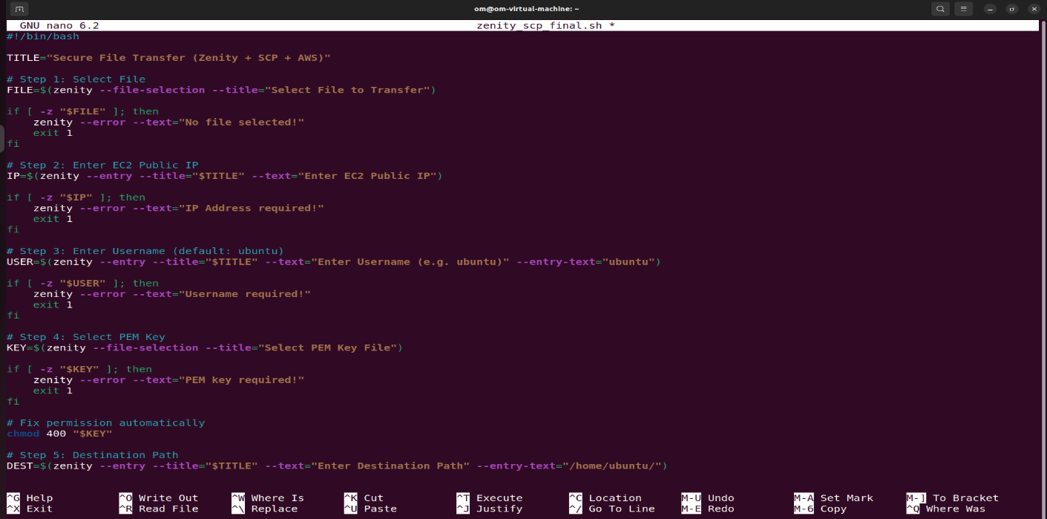

🔐 5. Make Executable
Command : chmod +x zenity_scp_final.sh

▶️ 6. Run Project
Command : ./zenity_scp_final.sh

7. Workflow (Write in Report)
- User selects file using Zenity GUI
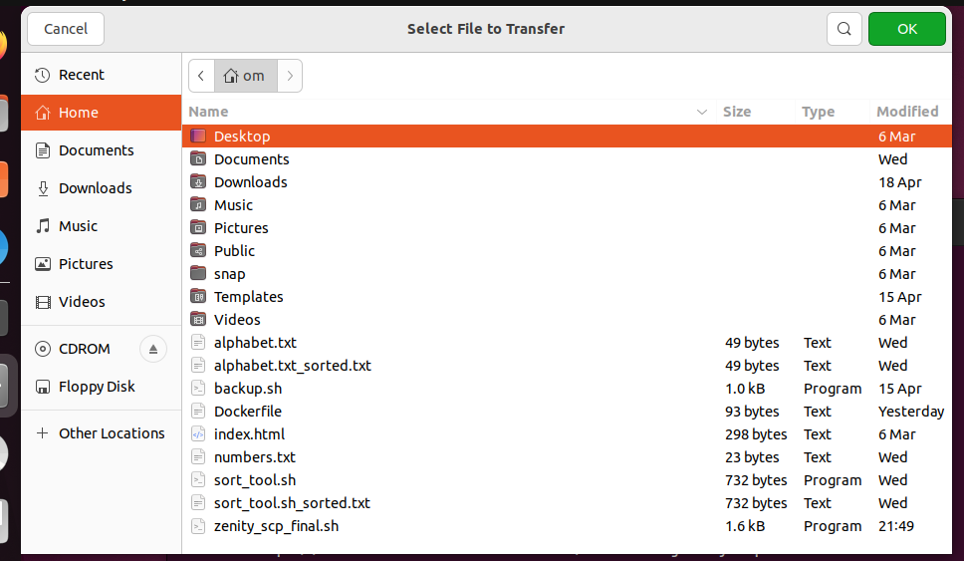

- User enters EC2 Public IP
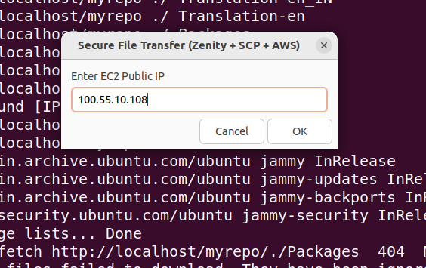

- User enters username (ubuntu)
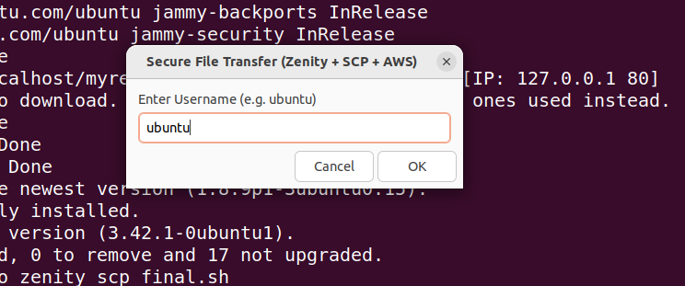

- User selects PEM key file


- Success/error message displayed
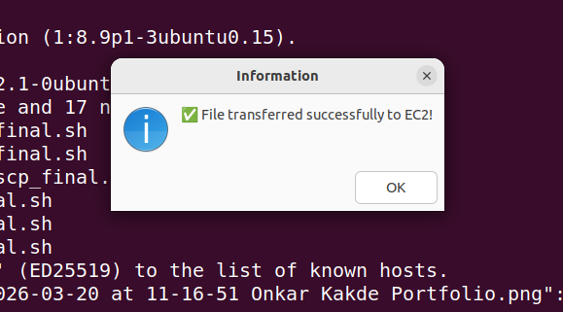

Aws console :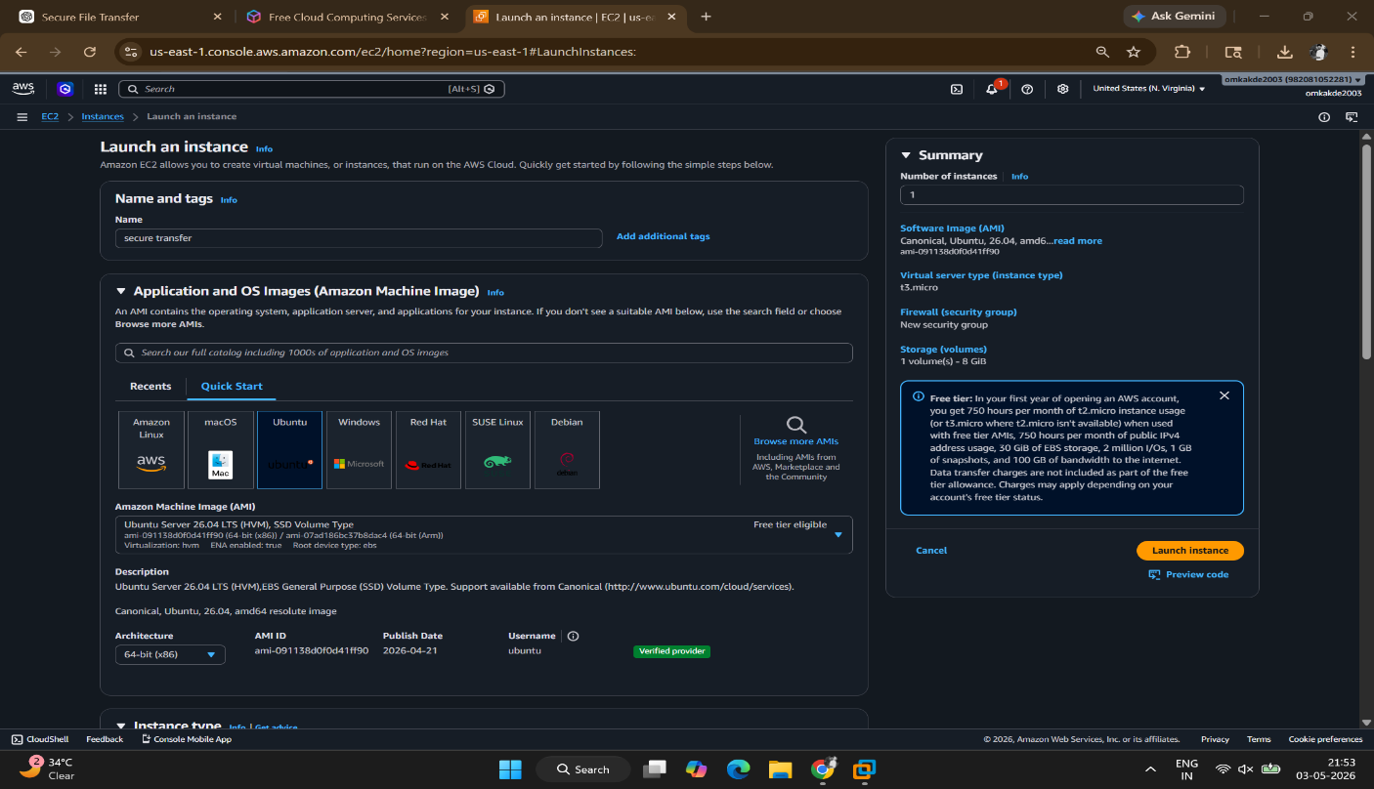

Architecture for project
